**Project Design Phase-II**

**Data Flow Diagram & User Stories**

|  |  |
| --- | --- |
| Date | 26 October 2022 |
| Team ID | PNT2022TMID51029 |
| Team Leader | Shriya R |
| Project Name | Gas Leakage Monitoring and Alerting System |
| Maximum Marks | 4 Marks |

**Data Flow Diagrams:**

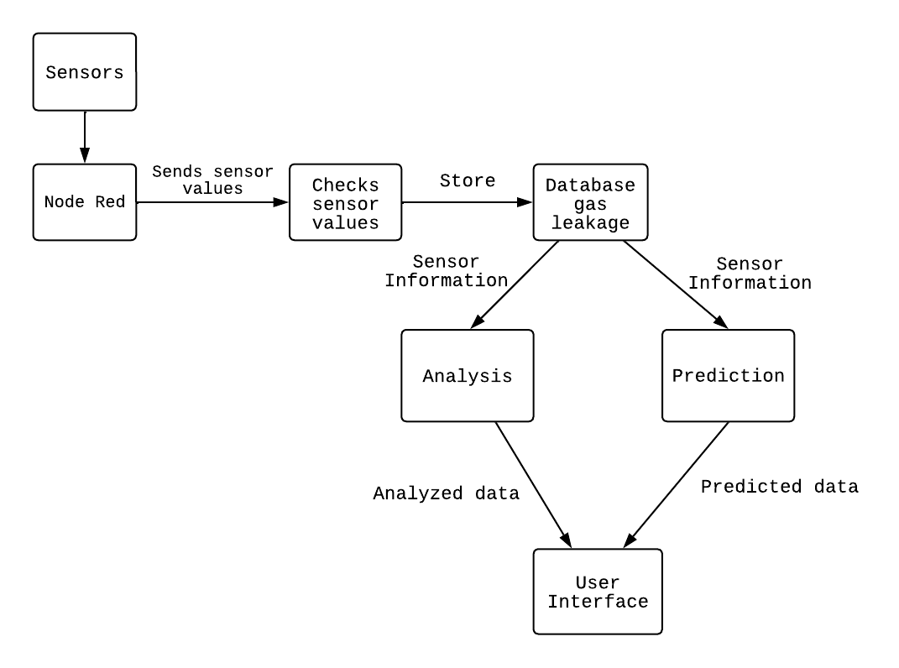

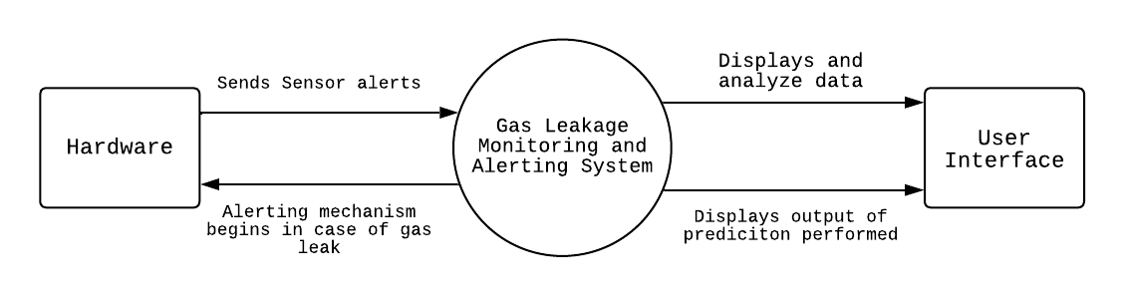



**User Stories:**

| **User Type** | **Functional Requirement (Epic)** | **User Story Number** | **User Story / Task** | **Acceptance criteria** | **Priority** | **Release** |
| --- | --- | --- | --- | --- | --- | --- |
| Customer (Mobile user) | Registration | USN-1 | My email address, password, and password confirmation are required for me to register for the application as a user. | I can access my account / dashboard | High | Sprint-1 |
|  |  | USN-2 | When I register for the application as a user, I will get a confirmation email. | I can receive confirmation email & click confirm | High | Sprint-1 |
|  | Login | USN-3 | By providing my email address and password, I can access the application as a user. | I can login into my account | High | Sprint-1 |
|  | Dashboard | USN-4 | The user may see the temperature. | I can view the data given by the device | High | Sprint-2 |
|  |  | USN-5 | The user may see the level of gas. | I can view the data given by the device | High | Sprint-2 |
| Customer (Web user) | Usage | USN-1 | The user can access the website and obtain the data. | I can view the data given by the device | High | Sprint-3 |
| Customer | Working | USN-1 | User responds as directed by the device's alert. | I can get the data work according to it | High | Sprint-3 |
|  |  | USN-2 | When a leak develops, the user activates the exhaust fan or sprinkler. | I can get the data work according to it | High | Sprint-4 |
| Customer Care Executive | Action | USN-1 | When someone encounters any usage problems, the user resolves the issue. | When someone doesn't comprehend the process, I can fix the problem | High | Sprint-4 |
| Administrator | Administration | USN-1 | User maintains all information. | The knowledge I have acquired can be stored | High | Sprint-4 |